PROJECT DESIGN PHASE – II

Technology Stack (Architecture & Stack)

Date | 06 July 2026
Project Domain | ServiceNow
Project Name | Smart Library Request Workflow in ServiceNow
Maximum Marks

Technical Architecture
The Smart Library Request Workflow in ServiceNow is designed to automate book request
handling using a centralized platform. It includes user interaction through the portal, backend workflow processing, database storage, and notification services.

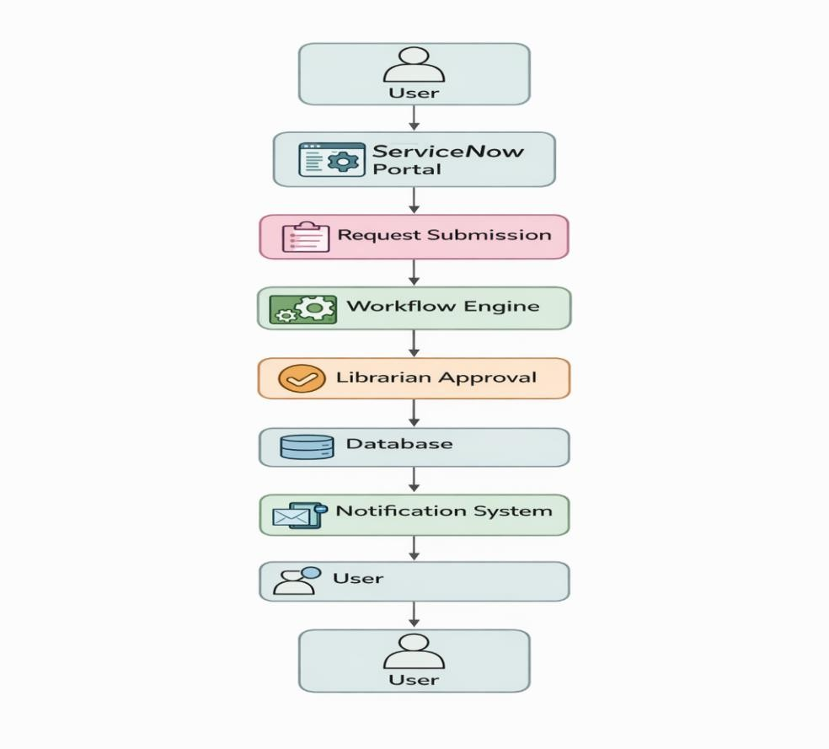

Table 1: Components

S /No | Component | Description | Technology
1 | User Interface | Users interact through portal (request, track status) | ServiceNow Portal
2 | Application Logic-1 | Request submission logic | ServiceNow Flow Designer
3 | Application Logic-2 | Approval workflow (librarian actions) | ServiceNow Workflow
4 | Application Logic-3 | Notification handling logic | ServiceNow Notifications
5 | Database | Stores request, user and status data | ServiceNow Tables
6 | Cloud Database | Data stored in cloud environment | ServiceNow Cloud
7 | File Storage | Store request-related documents (if any) | ServiceNow Attachments
8 | External API-1 | Email notification integration | SMTP / Email Service
9 | External API-2 | Optional integration (SMS/alerts) | REST API
10 | Machine Learning Model | Not applicable (basic workflow system) | —
11 | Infrastructure (Server/Cloud) | Application hosted on cloud platform | ServiceNow Cloud Platform

Table 2: Application Characteristics

S/No | Characteristics | Description | Technology
1 | Open-Source Frameworks | Platform-based development | ServiceNow Platform
2 | Security  Implementations | Role-based access, authentication | ServiceNow ACL
3 | Scalable Architecture | Handles multiple users and requests | Cloud-based architecture
4 | Availability | System available anytime (24/7) | ServiceNow Cloud
5 | Performance | Fast request processing and response | Optimized workflows

